

PRESS RELEASE Prague, 26th October 2016

The two newest BB Centrum buildings announce full occupancy

BB Centrum, the multifunctional complex in Prague 4 has full occupancy in its two newest office buildings, Building G and DELTA. The DELTA building’s current tenants have been joined by: PRO.MED.CS Praha (an independent pharmaceutical company), ABB (a company operating in the area of energy and automation), Trend Micro (EMEA) Limited (a company developing security software) and Green Light Solutions (a start-up oriented on software products). HEWLETT-PACKARD has also completed the second phase of its move into its new offices. Klüber Lubrication CZ, a company for the production of lubrication moved into Building G starting from October, from November Škoda JS, a supplier of technology for nuclear energy, will be headquartered here and the administrative part of the TeamPrevent-Santé private health-care network will be moving into Building G at the beginning of December.

The DELTA Building, the newest addition to the office buildings in Prague’s BB Centrum, has leased its last free space and now has all 41 400 m² of space occupied. Thus the new tenants have become neighbours to Microsoft, Skype Czech Republic, HEWLETT-PACKARD and HP Inc. Czech Republic. The DELTA building was designed by the architecture office Aulík Fišer architekti and this year it obtained BREEAM certification on the level of Very Good.

The intimately conceived Building G, the 11th office building in BB Centrum, with a leasable area of 5 700 m² of office space on four storeys and 1000 m² of retail space on the ground floor, comes from the ATELIER 8000 architecture studio. It was completed in 2013 and last year it acquired BREEAM certification on the level of Very Good. The tenants in Building G include: Mars Multisales Central Europe, Royal Canin Czech & Slovak Republics, FIAT CHRYSLER AUTOMOBILES ČR and SII.

“Both Building G and DELTA are easily accessible both by mass transit and by car. There is an abundance of parking spaces for tenants as well as parking for visitors and the public. Like most of the buildings in BB Centrum, both of the buildings have their own rooftop terrace with greenery and pleasant seating. Building G can boast a beautifully landscaped green courtyard that is available to all the tenants, while there is a unique river channel and other water features by the DELTA building. There is a wide selection of restaurants, shops and other services that BB Centrum provides as part of the building or within short walking distance. I am glad that the companies that chose BB Centrum for their headquarters or for operating their business have managed to appreciate not only the prime office spaces, but also the other BB Centrum advantages. I am very pleased the companies consider BB Centrum to be a good address,” added Vladimír Klouda, the Executive Director of PASSERINVEST GROUP.

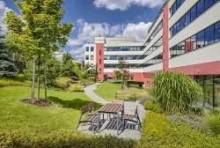

Building G at BB Centrum in Prague

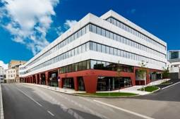

Building G at BB Centrum in Prague

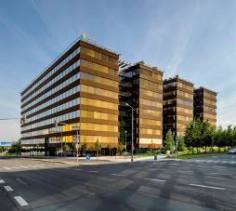

Building DELTA at BB Centrum in Prague

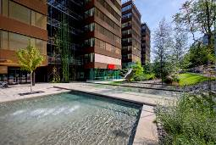

Building DELTA at BB Centrum in Prague

For more information and photographs in print quality please contact:

Kristýna Samková, Head of Marketing and PR
PASSERINVEST GROUP, a.s.
Tel.: (+420) 221 582 111
Mobil: (+420) 602 186 708
E-mail: Kristyna.Samkova@Passerinvest.cz
www.passerinvest.cz, www.bbcentrum.cz

Marcela Štefcová
Crest Communications a.s.
Tel.: (+420) 222 927 125
Mobile: (+420) 731 613 669
E-mail: marcela.stefcova@crestcom.cz
www.crestcom.cz

ABOUT THE DEVELOPER

PASSERINVEST GROUP, a. s., is a purely Czech development company, whose name is primarily connected with the construction of the multifunctional BB Centrum complex in Prague 4 – Michle. The company, founded in 1991 by Radim Passer, built a very good name on both a domestic and international level with this, the most successful and extensive Czech project of its kind. This is not only due to the quality of the implemented projects and the high level of provided services, but also to a sense of fair play, an accommodating relationship with the tenants/users of the buildings and the responsibility towards society and the environment. PASSERINVEST GROUP also has other interesting development projects in its portfolio.

